|  |
| --- |
| **DAYANANDA SAGAR UNIVERSITY**  Devarakaggalahalli, Harohalli  Kanakapura Road, Ramanagara - 562112, Karnataka, India   |

**Bachelor of Technology**

**in**

**COMPUTER SCIENCE AND ENGINEERING**

**Full Stack Development**

**Mini Project Report**

**(ONLINE BIKE ACCESSORIES)**

By

**Lohithvarma R ENG22CS0351**

**P Kaushik ENG22CS0380**

**Mohamed Rabeeb ENG22CS0369**

**Rithvik Krishna ENG22CS0415**

**Under the supervision of**

**Dr./Mr.Sharath Heggur**

**Designation and Department of Guide**

**DEPARTMENT OF COMPUTER SCIENCE & ENGINEERING,**

**SCHOOL OF ENGINEERING**

**DAYANANDA SAGAR UNIVERSITY, (2023-2024**

**DAYANANDA SAGAR UNIVERSITY**

Department of Computer Science & Engineering

Devarakaggalahalli, Harohalli

Kanakapura Road, Ramanagara - 562112, Karnataka, India

CERTIFICATE

This is to certify that the Full Stack Development Mini Project work titled **“TITLE”** is carried out by Lohithvarma.R (ENG22CS0351)**,**P.Kaushik (ENG22CS0380), Mohamed Rabeeb(ENG22CS0369),Rithvik Krishna(ENG22CS0415) bonafide students of Third semester of Bachelor of Technology in Computer Science and Engineering at the School of Engineering, Dayananda Sagar University, Bangalore in partial fulfillment for the award of degree in Bachelor of Technology in Computer Science and Engineering, during the year **2023-2024**.

|  |  |
| --- | --- |
| **Sharath Heggur** | **Dr. Girisha G S** |
| Professor  Dept. of CS&E,  School of Engineering  Dayananda Sagar University  Date: : 04.01.2024 | Chairman CSE  School of Engineering  Dayananda Sagar University  Date: 04.01.2024 |

**Name of the Examiner** **Signature of Examiner**

<

DECLARATION

We, Lohithvarma.R (ENG22CS0351)**,**P.Kaushik (ENG22CS0380), Mohamed Rabeeb(ENG22CS0369),Rithvik Krishna(ENG22CS0415)are students of Third semester B. Tech in **Computer Science and Engineering**, at School of Engineering, **Dayananda Sagar University**, hereby declare that the Mini Project titled **“ONLINE BIKE ACCESSORIES”** has been carried out by us and submitted in partial fulfilment for the award of degree in **Bachelor of Technology in Computer Science and Engineering** during the academic year **2023‑2024.**

|  |  |
| --- | --- |
| Student | Signature |
| Name1:Lohithvarma R  USN :ENG22CS0351 |  |
| Name2:Kauhik P  USN :ENG22CS0380 |  |
| Name3:Mohamed Rabeeb  USN :ENG22CS0369 |  |
| Name4:Rithvik Krishna  USN :ENG22CS0415 |  |
| Place : Bangalore  Date : 04.01.2024 |  |

**ACKNOWLEDGEMENT**

*It is a great pleasure for us to acknowledge the assistance and support of many individuals who have been responsible for the successful completion of Full Stack Development mini project work.*

*First, we take this opportunity to express our sincere gratitude to School of Engineering & Technology, Dayananda Sagar University for providing us with a great opportunity to pursue our Bachelor’s degree in this institution.*

*We would like to thank* ***Dr. Udaya Kumar Reddy K R, Dean, School of Engineering & Technology, Dayananda Sagar University*** *for his constant encouragement and expert advice.*

*It is a matter of immense pleasure to express our sincere thanks to* ***Dr. Girisha G S,******Department Chairman****,* ***Computer Science and Engineering****,* ***Dayananda Sagar University,*** *for providing right academic guidance that made our task possible.*

*We would like to thank our guide* ***Sharath Heggur******Professor****,* ***Dept. of Computer Science and Engineering****,* ***Dayananda Sagar University****, for sparing his/her valuable time to extend help in every step of our project work, which paved the way for smooth progress and fruitful culmination of the project.*

*We are also grateful to our family and friends who provided us with every requirement throughout the course.*

*We would like to thank one and all who directly or indirectly helped us in the mini Project work.*

**TABLE OF CONTENTS**

LIST OF FIGURES

ABSTRACT

Page

CHAPTER 1 INTRODUCTION………................................................................. 8

CHAPTER 2 OVERVIEW OF PROJECT……..................................................... 8

2.1. Purpose and Goals.......................................................................... 9

2.2. Technologies Used........................................................................... 9

CHAPTER 3 FUNCTIONAL REQUIREMENTS..................................................... 10

CHAPTER 4 CODE SNIPPETS………...................................................................... 11

CHAPTER 5 RESULT………………………........................................................... 26

CONCLUSION……………………………………………………………………... 29

**LIST OF FIGURES**

|  |  |  |
| --- | --- | --- |
| Fig. No. | Description of the figure | Page No. |
| 4.1(a) | Main Page, Products Page | 26 |
| 4.1(b) | Contacts and Product Catalogue | 27 |
| 4.2(a) | Login Page | 28 |

Abstract

The "Online Bike Accessory Shop" project aims to create a user-friendly and efficient online platform dedicated to providing a wide range of accessories for bike enthusiasts. The project leverages modern web technologies to create a seamless shopping experience for users interested in purchasing high-quality and diverse bike accessories.

CHAPTER 1 INTRODUCTION

The purpose of the "Online Bike Accessory Shop" project is to create a digital platform that caters to the needs and preferences of bike enthusiasts, providing them with a convenient and efficient way to access a wide range of high-quality bike accessories.

**CHAPTER 2 OVERVIEW OF PROJECT**

* The Online Bike Accessory Shop is a digital platform dedicated to providing bike enthusiasts with a convenient and comprehensive online shopping experience for a wide range of bike accessories. The platform aims to cater to the diverse needs of cyclists, offering products that enhance safety, performance, aesthetics, and overall biking enjoyment. Here is an overview of the key components and features:

1. Product Catalog:

* A curated and diverse catalog of bike accessories, including but not limited to helmets, locks, lights, clothing, tools, and more.
* Products are organized into categories for easy navigation.

2. User-Friendly Interface:

* An intuitive and user-friendly website or application interface designed to enhance the overall shopping experience.
* Easy navigation, search functionality, and clear product displays contribute to a seamless user experience.

3. Product Information:

* Detailed product pages with high-quality images, specifications, features, and customer reviews.
* Comprehensive information to assist customers in making informed purchasing decisions.

4. Community Engagement:

* User reviews and ratings for products to foster a sense of community among bike enthusiasts.
* Forums or discussion boards where customers can share experiences, recommendations, and tips.

5. Responsive Design:

* A responsive and mobile-friendly design to ensure a consistent and enjoyable shopping experience across various devices.8. Admin Panel:
* An efficient admin panel for managing product listings, inventory, and order processing.
* Analytics and reporting tools to gain insights into customer behavior and sales trends.

**2.1. Purpose and Goals**

The purpose of an Online Bike Accessory Shop is to provide a digital platform where customers, particularly bike enthusiasts, can conveniently explore, select, and purchase a variety of accessories for their bikes

**2.2. Technologies Used**

* HTML
* CSS
* JAVA SCRIPT

**CHAPTER 3 FUNCTIONAL REQUIREMENTS**

* **windows 8,9,10,11 or basic mac versions**
* **minimum of 4gb ram**
* **browser mentioned below**

1. **google chrome**
2. **microsoft edge**
3. **safari**

**CHAPTER 4 CODE SNIPPETS**

1. **HTML**

* **Main Page**
* <!DOCTYPE html>
* <html lang="en">
* <head>
* <meta charset="UTF-8">
* <meta http-equiv="X-UA-Compatible" content="IE=edge">
* <meta name="viewport" content="width=device-width, initial-scale=1.0">
* <title>Get Your Gears</title>
* <link rel="stylesheet" href="styles.css">
* </head>
* <body>
* <header>
* <a href="#home" class="logo">Gear Heads</a>
* <nav>
* <a href="#home" class="active" >Home</a>
* <a href="#products">Products</a>
* <a href="#about">About</a>
* <a href="#contact">Contact</a>
* <a href="login.html" target="_blank">Login</a>
* </nav>
* </header>
* <div class="color-bar"></div>
* <section id="home" >
* <center>
* Welcome to <b>Gear Heads</b><br>
* Your Ultimate Destination for Motorcycle Wearing Accessories!
* <br><br>
* At Gear Heads, we believe that riding is not just a passion; it's a lifestyle.<br>
* Whether you're cruising through city streets, tackling rugged terrains, or hitting the open highway, <br>
* we understand the importance of having the right gear that not only offers protection but also reflects your style and individuality.
* </center>
* </section>
* <section id="products"><center>
* <nav >
* <a href="rynox.html" >
* <img src="rynox logo.png" alt="rl" width="20%">
* </a>
* <a href="dianese.html">
* <img src="Dainese-logo.png" alt="rl" width="20%">
* </a>
* <a href="agv.html">
* <img src="agv logo.png" alt="rl" width="20%">
* </a>
* </nav>
* </center>
* </section>
* <section id="about">
* <center>
* About Us:
* <br>
* Established with a deep love for the open road, Gear Heads is more than just an online store;<br>
* it's a hub for motorcycle enthusiasts seeking <br> top-quality riding gear and accessories.
* Our mission is to provide riders with a curated selection of products that blend safety, style, and innovation.
* <br><br></center>
* <br>
* Why Choose Gear Heads?
* <br>
* 1.Premium Quality: We source our products from reputable brands known for their commitment to quality and safety. Each item in our collection undergoes rigorous testing to ensure it meets the highest standards.
* <br>
* 2.Style Meets Safety: We understand that your gear is an extension of your personality. That's why we offer a diverse range of products that not only prioritize safety but also showcase the latest trends in motorcycle fashion.
* <br>
* 3.Customer Satisfaction: Your satisfaction is our priority. We strive to provide a seamless shopping experience, from easy navigation on our website to swift and secure deliveries.
* <br>
* 4.Community Connection: Join our community of riders on social media. Share your experiences, get involved in discussions, and stay updated on the latest trends in the motorcycle world.
* <br>
* Gear up for the ride of your life with Gear Heads. Embrace the road with confidence, style, and unparalleled protection. Your journey begins here!
* </center>
* </section>
* <section id="contact">
* <center>
* Contact Us:<br>
* ✉:gearheads@gmail.com
* <br>
* ⓕ:Gear  Heads
* <br>
* ✆:+91-8657426523
* <br>
* Mon-Fri 11.00 AM to 4.30 PM
* <br>
* <br>
* <b>© 2024,Gear Heads</b>
* </center>
* </section>
* <script src="script.js"></script>
* </body>
* </html>
* **Dianese.html**
* <!DOCTYPE html>
* <html>
* <head>
* <meta charset="UTF-8">
* <meta http-equiv="X-UA-Compatible" content="IE=edge">
* <meta name="viewport" content="width=device-width, initial-scale=1.0">
* <link rel="stylesheet" href="gear.css">
* <title>Dianese Gears</title>
* </head>
* <body>
* <header>
* <a href="html.html#home" class="logo">Gear Heads</a>
* <nav>
* <a href="html.html#products">Products</a>
* <a href="dianese.html" >Dianese</a>
* </nav>
* </header>
* <div class="color-bar"></div>
* <section id="dianese">
* <div class="parent">
* <div>
* <img src="dianeseavro.png" alt="avro" width="30%";>
* <h2>Dainese Avro 4 2Pc Leather Suit</h2>
* <p>Price:₹120,000.00 <sub>MRP inclusive of all taxes</sub></p>
* <button class="btn " onclick="window.open('https://www.motomadness.in/product-page/Dainese-avro-4-2pc-leather-suit-3')">Buy now</button>
* </div>
* <div>
* <img src="dianese smart.png" alt="smart jacket" width="30%";>
* <h2>Dainese Smart Jacket LS Sport</h2>
* <p>Price:₹115,000.00 <sub>MRP inclusive of all taxes</sub></p>
* <button class="btn " onclick="window.open('https://www.motomadness.in/product-page/dainese-smart-jacket-ls-sport')">Buy now</button>
* </div>
* <div>
* <img src="thermo.png" alt="thermal layer" width="30%";>
* <h2>Dainese Thermo LS (Thermal Inner Wear)</h2>
* <p>Price:₹9,500.00 <sub>MRP inclusive of all taxes</sub></p>
* <button class="btn " onclick="window.open('https://www.motomadness.in/product-page/Dainese-thermo-ls-thermal-innerwear')">Buy now</button>
* </div>
* </div>
* <br>
* <br>
* <div class="parent">
* <div>
* <img src="axial d1.png" alt="axial d1" width="30%";>
* <h2>Dainese Axial D1 Boots</h2>
* <p>Price:₹60,000.00 <sub>MRP inclusive of all taxes</sub></p>
* <button class="btn " onclick="window.open('https://www.motomadness.in/product-page/dainese-axial-d1-boots')">Buy now</button>
* </div>
* <div>
* <img src="solorys.png" alt="solorys" width="30%";>
* <h2>Dainese Solarys Gore-Tex Boots</h2>
* <p>Price:₹33,000.00 <sub>MRP inclusive of all taxes</sub></p>
* <button class="btn " onclick="window.open('https://www.motomadness.in/product-page/Dainese-solarys-gore-tex-boots')">Buy now</button>
* </div>
* <div>
* <img src="dmach.png" alt="dmach" width="30%";>
* <h2>Dainese D-Mach Compact Backpack</h2>
* <p>Price:₹22,000.00 <sub>MRP inclusive of all taxes</sub></p>
* <button class="btn " onclick="window.open('https://www.motomadness.in/product-page/Dainese-d-mach-compact-backpack')">Buy now</button>
* </div>
* </div>
* </section>
* </body>
* </html>
* **Rynox.html**
* <!DOCTYPE html>
* <html>
* <head>
* <meta charset="UTF-8">
* <meta http-equiv="X-UA-Compatible" content="IE=edge">
* <meta name="viewport" content="width=device-width, initial-scale=1.0">
* <link rel="stylesheet" href="gear.css">
* <title>Rynox Gears</title>
* </head>
* <body>
* <header>
* <a href="html.html#home" class="logo">Gear Heads</a>
* <nav>
* <a href="html.html#products">Products</a>
* <a href="rynox.html" >Rynox</a>
* </nav>
* </header>
* <div class="color-bar"></div>
* <section id="rynox">
* <div class='parent'>
* <div>
* <img src="URBANXJACKET.png.webp" alt="Urban Jacket" width="30%">
* <h2>URBAN X JACKET 2023</h2>
* <p>Price:₹7,550.00 <sub>MRP inclusive of all taxes</sub></p>
* <button class="btn " onclick="window.open('https://rynoxgear.com/collections/jackets/products/rynox-urban-x-jacket-camo-hex-black')">Buy now</button>
* </div>
* <div>
* <img src="RynoxTorandoPro4Jacke.png" alt="Tornado Jacket" width="30%";>
* <h2>Tornado Pro 4 Jacket</h2>
* <p>Price:₹8,950.00 <sub>MRP inclusive of all taxes</sub></p>
* <button class="btn " onclick="window.open('https://rynoxgear.com/collections/jackets/products/rynox-tornado-pro-4-jacket-black-orange-hiviz-green-white-red-all-black?variant=39428153049155')">Buy now</button>
* </div>
* <div>
* <img src="tridentjacket.png" alt="Trident Jacket" width="30%">
* <h2>Trident-10 YEAR ANNIVERSARY EDITION</h2>
* <p>Price:₹16,990.00 <sub>MRP inclusive of all taxes</sub></p>
* <button class="btn " onclick="window.open('https://rynoxgear.com/collections/jackets/products/trident-jacket')">Buy now</button>
* </div>
* </div>
* <br>
* <br>
* <div class="parent">
* <div>
* <img src="Rynox_Dry_Ice_Waterproof_Winter_Gloves.png" alt="dry ice glove" width="30%";>
* <h2>Dry Ice Waterproof Winter Gloves</h2>
* <p>Price:₹4,250.00 <sub>MRP inclusive of all taxes</sub></p>
* <button class="btn " onclick="window.open('https://rynoxgear.com/collections/gloves/products/dry-ice-waterproof-winter-gloves-black-blue')">Buy now</button>
* </div>
* <div>
* <img src="RynoxGravelDualSportGloves.png" alt="gravel dualsport" width="30%";>
* <h2>Gravel DualSport Gloves</h2>
* <p>Price:₹3,250.00 <sub>MRP inclusive of all taxes</sub></p>
* <button class="btn " onclick="window.open('https://rynoxgear.com/collections/gloves/products/gravel-gloves?variant=39756471533635')">Buy now</button>
* </div>
* <div>
* <img src="RynoxH2GoProRainPants.png" alt="h2gopro" width="30%";>
* <h2>H2Go Pro Rain Pants</h2>
* <p>Price:₹1,350.00 <sub>MRP inclusive of all taxes</sub></p>
* <button class="btn " onclick="window.open('https://rynoxgear.com/products/h2go-pro-rain-pants-black-hiviz-green?variant=40199930740803&currency=INR&utm_source=google&utm_medium=cpc&utm_campaign=SP_Search_DSA_19th_June_23&utm_adgroup=&utm_term=&utm_network=Searchg&utm_matchtype=&utm_device=c&utm_placement=&utm_content=663106663811&utm_location=9062009&utm_Audience=dsa-42031557773&utm_campaignid=20295823093&utm_adgroupid=153348951071&gad_source=1&gclid=CjwKCAiA4smsBhAEEiwAO6DEjb0Z3iEBGMM1VVjnMp1T7Qk9ovP4mS3YRquVV-ZftwhDOj8Am7uUAhoCPGYQAvD_BwE')">Buy now</button>
* </div>
* </div>
* <footer>
* <center>
* <br><br><br>
* Mon-Fri | 11.00 AM to 4.30 PM
* <br>
* <b>© 2024,Gear Heads</b>
* </center>
* </footer>
* </body>
* </html>
* **Agv.html**

<!DOCTYPE html>

<html>

    <head>

        <meta charset="UTF-8">

        <meta http-equiv="X-UA-Compatible" content="IE=edge">

        <meta name="viewport" content="width=device-width, initial-scale=1.0">

        <link rel="stylesheet" href="gear.css">

        <title>AGV Helmets</title>

    </head>

    <body>

        <header>

            <a href="html.html#home" class="logo">Gear Heads</a>

            <nav>

                <a href="html.html#products">Products</a>

                <a href="agv.html" >AGV</a>

            </nav>

            </header>

            <div class="color-bar"></div>

        <section id="agv">

            <div class="parent">

                <div>

                    <img src="k6.png" alt="k6" width="30%";>

                    <h2>AGV K6 S DOT Excite-Matt Camo/Yellow Fluo</h2>

                    <p>Price:₹60,000.00 <sub>MRP inclusive of all taxes</sub></p>

                    <button class="btn " onclick="window.open('https://www.pathpavers.in/products/agv-k6-s-dot-excite-matt-camo-yellow-fluo')">Buy now</button>

                  </div>

                  <div>

                    <img src="k3.png" alt="k3" width="30%";>

                    <h2>AGV K3 E2206 MPLK Decept Matt Black/Green/Red</h2>

                    <p>Price:₹35,500.00 <sub>MRP inclusive of all taxes</sub></p>

                    <button class="btn " onclick="window.open('https://www.pathpavers.in/products/agv-k3-e2206-mplk-decept-matt-black-green-red')">Buy now</button>

                  </div>

                  <div>

                    <img src="k3sv.png" alt="dmach" width="30%";>

                    <h2>AGV K3SV Rossi Mugello 2017</h2>

                    <p>Price:₹25,500.00 <sub>MRP inclusive of all taxes</sub></p>

                    <button class="btn" onclick="window.open('https://www.pathpavers.in/products/agv-k3sv-mugello-2017-helmet?_pos=55&_fid=459c80889&_ss=c')">Buy now</button>

                  </div>

            </div>

            </section>

            </body>

* **Login.html**
* <!DOCTYPE html>
* <html>
* <head>
* <style>
* body {
* font-family: Arial, sans-serif;
* background-color: #1f242d;
* color: white;
* }
* .container {
* width: 300px;
* padding: 16px;
* background-color:#1f242d;
* margin:auto;
* margin-top: 200px;
* border-radius: 4px;
* }
* input[type=text], input[type=password] ,input[type=gmail]{
* width: 100%;
* padding: 10px ;
* margin:auto;
* display: inline-block;
* border: 1px solid #ccc;
* box-sizing: border-box;
* }
* input[type=submit] {
* background-color: #4CAF50;
* color: white;
* padding: 10px ;
* margin-top: 20px ;
* width: 100%;
* }
* input[type=submit]:hover {
* background-color: #45a049;
* }
* h1{color: white;}
* header {
* position: fixed;
* top: 0;
* left: 0;
* width: 100%;
* padding: 20px 120px;
* background: #11141a;
* display: flex;
* justify-content: space-between;
* align-items: center;
* z-index: 100;
* }
* .logo {
* font-size: 25px;
* color: #fff;
* text-decoration: none;
* font-weight: 600;
* }
* </style>
* <script src="log.js"></script>
* </head>
* <body>
* <header>
* <a href="html.html#home" class="logo">Gear Heads</a>
* </header>
* <center>
* <div class="container">
* <h1>Login</h1>
* <form name="myForm" action="" onsubmit="saveData(); return false;">
* <label for="uname"><b>Username</b></label>
* <input type="text" placeholder="Enter Username" name="uname" required>
* <br><br>
* <label for="psw"><b>Password</b></label>
* <input type="password" placeholder="Enter Password" name="psw" required>
* <br><br>
* <label for="gmail"><b>Gmail</b></label>
* <input type="text" placeholder="Enter Gmail" name="gmail" required>
* <input type="submit" value="Submit">
* </form>
* </div>
* </center>
* </body>
* </html>

1. **CSS**

* **Styles.css**
* @import url('https://fonts.googleapis.com/css2?family=Poppins:wght@300;400;500;600;700;800;900&display=swap');
* * {
* margin: 0;
* padding: 0;
* box-sizing: border-box;
* scroll-behavior: smooth;
* font-family: 'Poppins', sans-serif;
* }
* header {
* position: fixed;
* top: 0;
* left: 0;
* width: 100%;
* padding: 20px 120px;
* background: #11141a;
* display: flex;
* justify-content: space-between;
* align-items: center;
* z-index: 100;
* }
* .logo {
* font-size: 25px;
* color: #fff;
* text-decoration: none;
* font-weight: 600;
* }
* nav a {
* font-size: 18px;
* color: #fff;
* text-decoration: none;
* font-weight: 500;
* margin-left: 20px;
* transition: .3s;
* }
* nav a:hover,
* nav a.active {
* color: #0ef;
* }
* section {
* min-height: 100vh;
* display: flex;
* justify-content: center;
* align-items: center;
* background: #1f242d;
* font-size: 100px;
* color: #fff;
* font-weight: 1000;
* font-size:larger;
* }
* section:nth-child(odd) {
* background: #323946;
* background: url('bgi.png') no-repeat center center fixed;
* -webkit-background-size: cover;
* -moz-background-size: cover;
* -o-background-size: cover;
* background-size:cover;
* }
* .color-bar{
* width: 100%;
* height: 70px;
* color: #11141a;
* }
* **gears.css**
* @import url('https://fonts.googleapis.com/css2?family=Poppins:wght@300;400;500;600;700;800;900&display=swap');
* * {
* margin: 0;
* padding: 0;
* box-sizing: border-box;
* scroll-behavior: smooth;
* font-family: 'Poppins', sans-serif;
* }
* header {
* position: fixed;
* top: 0;
* left: 0;
* width: 100%;
* padding: 20px 120px;
* background: #11141a;
* display: flex;
* justify-content: space-between;
* align-items: center;
* z-index: 100;
* }
* .logo {
* font-size: 25px;
* color: #fff;
* text-decoration: none;
* font-weight: 600;
* }
* nav a {
* font-size: 18px;
* color: #fff;
* text-decoration: none;
* font-weight: 500;
* margin-left: 20px;
* transition: .3s;
* }
* nav a:hover,
* nav a.active {
* color: #0ef;
* }
* section {
* min-height: 100vh;
* justify-content: center;
* align-items: center;
* background: #1f242d;
* color: #fff;
* }
* div
* {
* padding: 10px;
* height: 300px;
* margin-top: auto;
* }
* .parent
* {
* display: flex;
* text-align: center;
* }
* .btn {
* background-color:#11141a;
* border: none;
* color:white;
* padding: 10px 20px;
* text-align: center;
* text-decoration: none;
* display: inline-block;
* font-size: 16px;
* margin: 4px 2px;
* cursor: pointer;
* }
* .btn:hover {
* background-color: black;
* }
* .color-bar{
* width: 100%;
* height: 70px;
* color: #11141a;
* }

1. **JavaScript**

* **Script.js**

1. let sections = document.querySelectorAll('section');
2. let navLinks = document.querySelectorAll('header nav a');
3. window.onscroll = () => {
4. sections.forEach(sec => {
5. let top = window.scrollY;
6. let offset = sec.offsetTop - 150;
7. let height = sec.offsetHeight;
8. let id = sec.getAttribute('id');
9. if(top >= offset && top < offset + height) {
10. navLinks.forEach(links => {
11. links.classList.remove('active');
12. document.querySelector('header nav a[href*=' + id + ']').classList.add('active');
13. });
14. };
15. });
16. };

* **Log.js**
* function saveData() {
* var uname = document.forms["myForm"]["uname"].value;
* var psw = document.forms["myForm"]["psw"].value;
* var gmail = document.forms["myForm"]["gmail"].value;
* localStorage.setItem("uname", uname);
* localStorage.setItem("psw", psw);
* localStorage.setItem("gmail", gmail);
* document.forms["myForm"]["uname"].value = "";
* document.forms["myForm"]["psw"].value = "";
* document.forms["myForm"]["gmail"].value = "";
* }

**CHAPTER 5 RESULT**

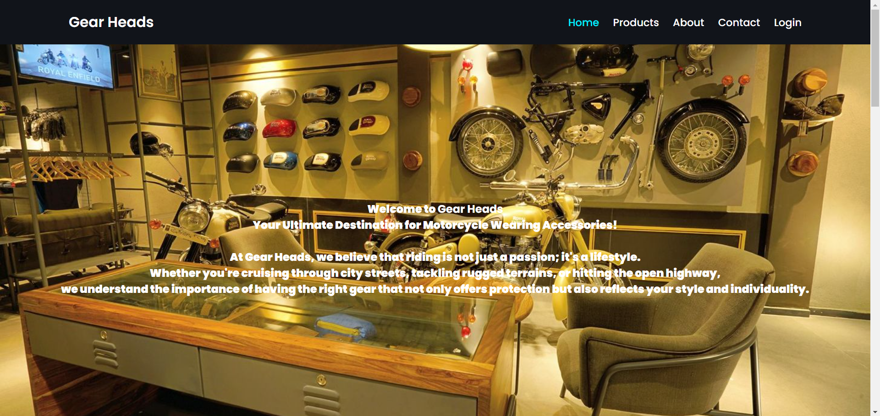

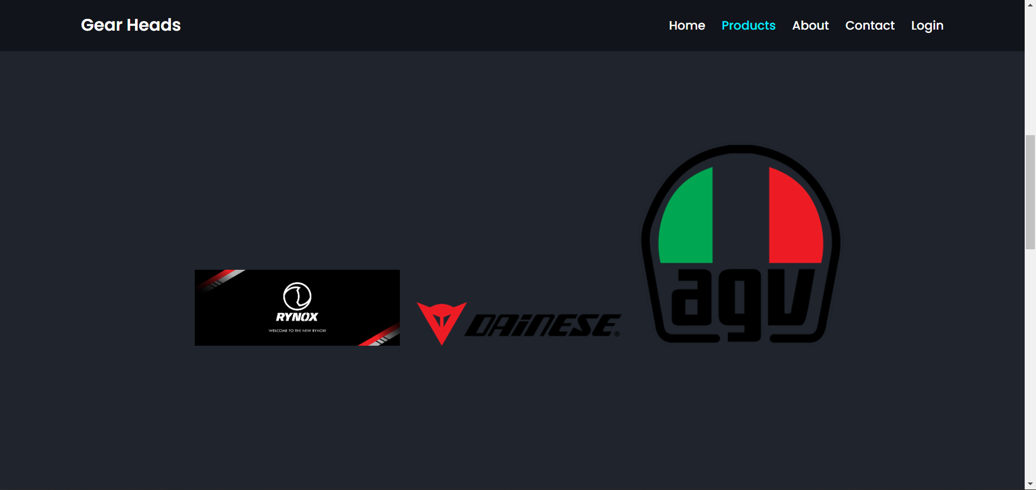

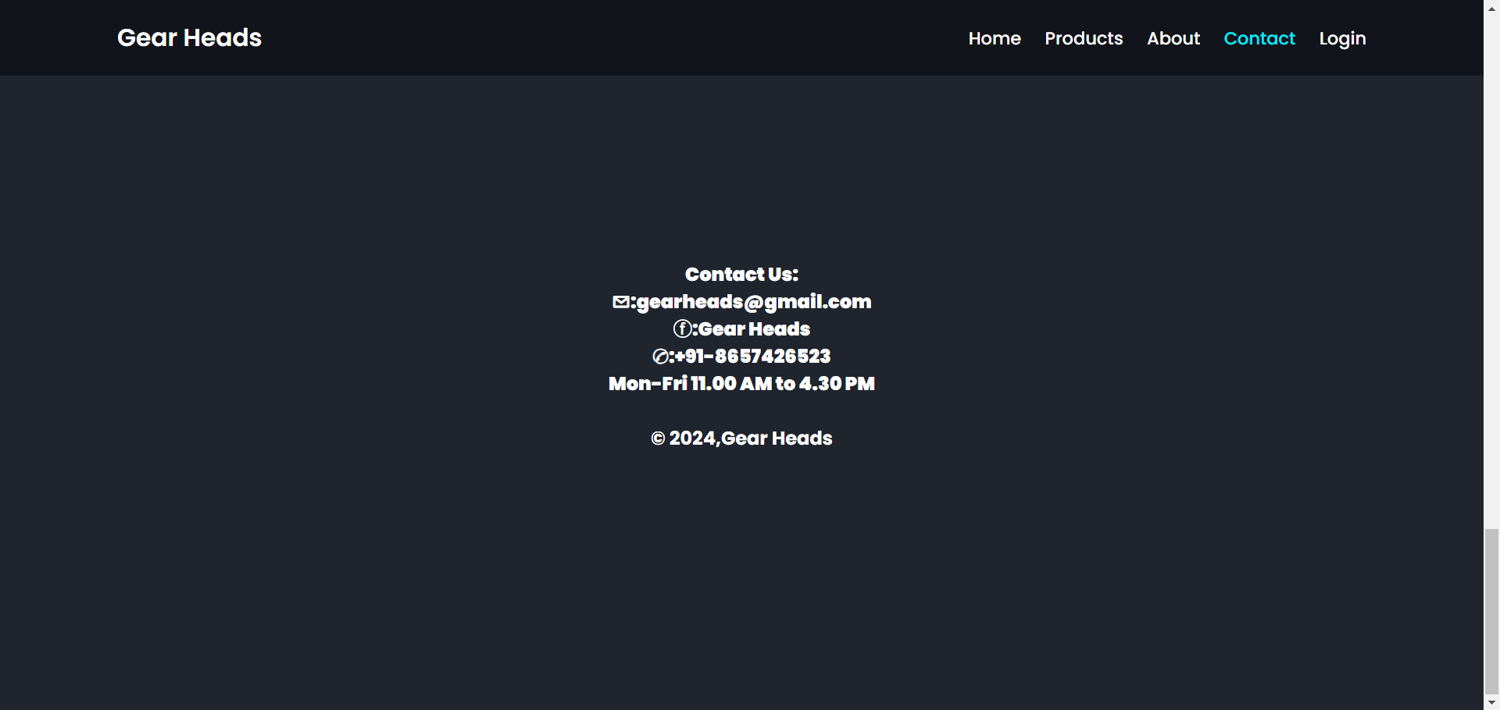

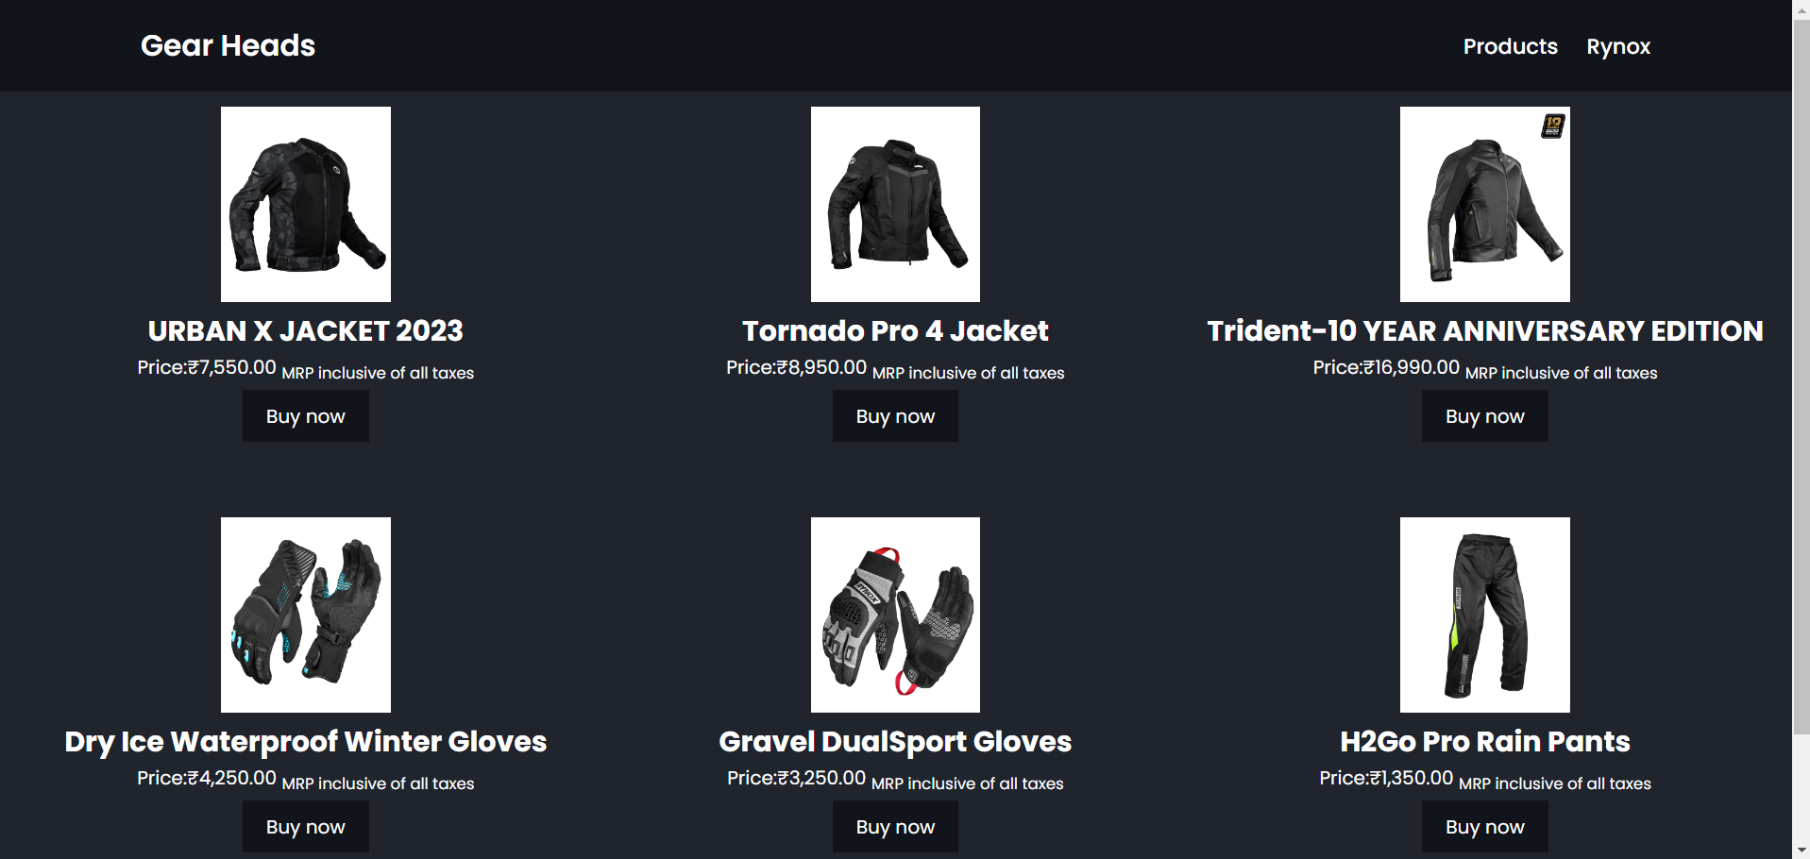

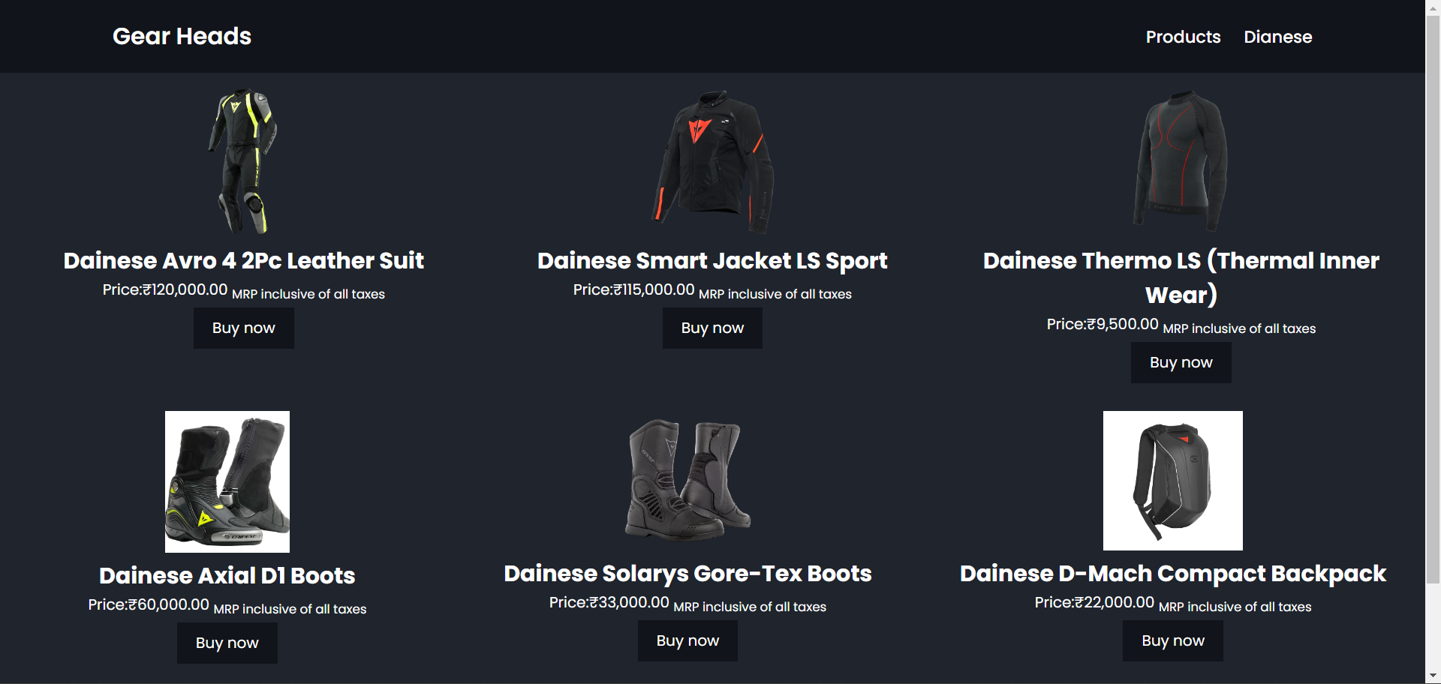

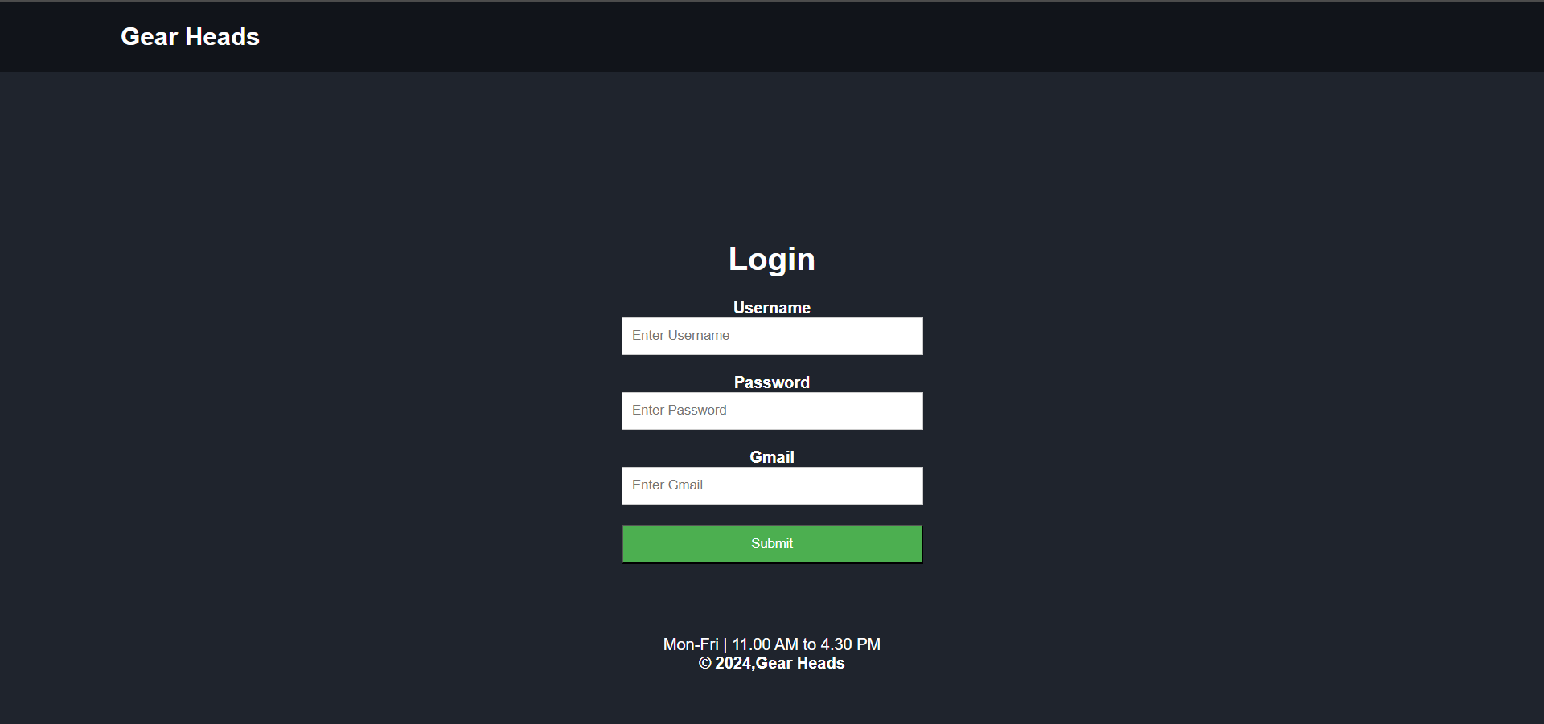

**CONCLUSION**

In conclusion, our bike accessories online project successfully integrates HTML, CSS, and JavaScript to create a user-friendly and visually appealing platform. The seamless navigation, responsive design, and interactive features enhance the overall shopping experience. By leveraging these technologies, we've not only established an efficient e-commerce website but also ensured a dynamic and engaging interface for users passionate about bike accessories.